ASSIGNMENT - DIGITAL MARKETING

|  |  |
| --- | --- |
| Reg No | 962820106029 |
| NAME | SALMAAN FARIS S K |
| NM ID | 930216F96B0ABD3920B497B36EED2C29 |
| Date | 22-10-2023 |

1.Create a blog or website using Blogspot and WordPress. Customize the theme design and post new article with 500 words.

Link: <https://pandachipspunch.blogspot.com/>

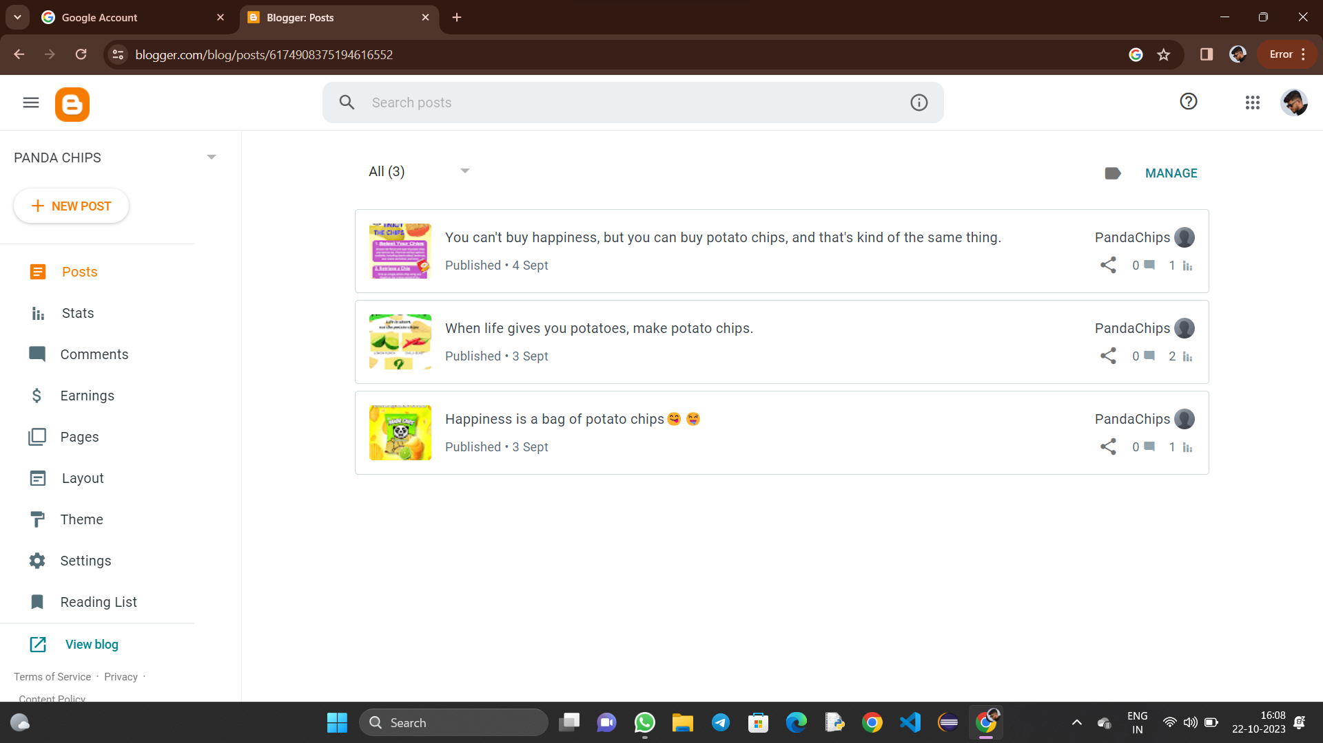

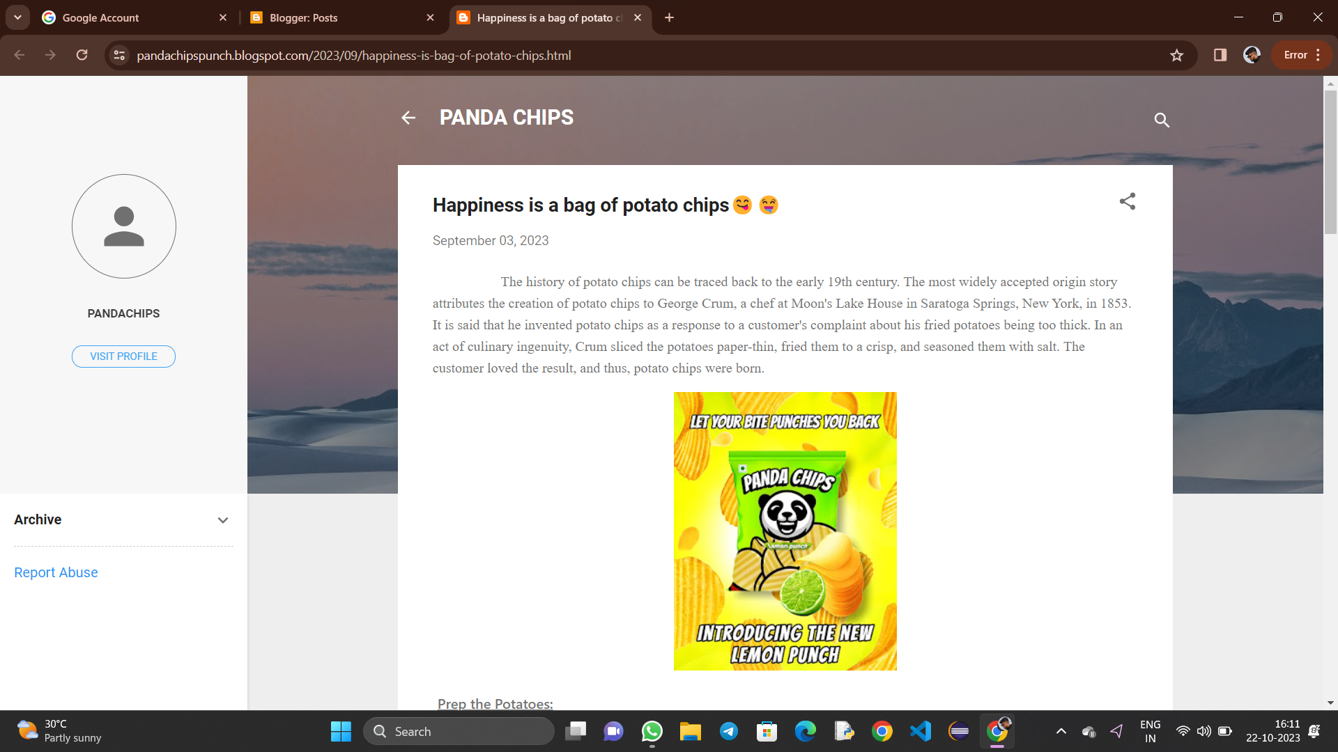

**2**.Create a new Facebook page and post one social media poster for your brand.

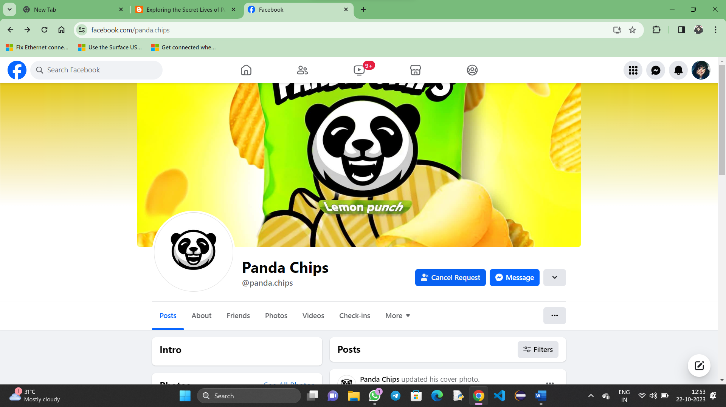Link: <https://www.facebook.com/panda.chips>

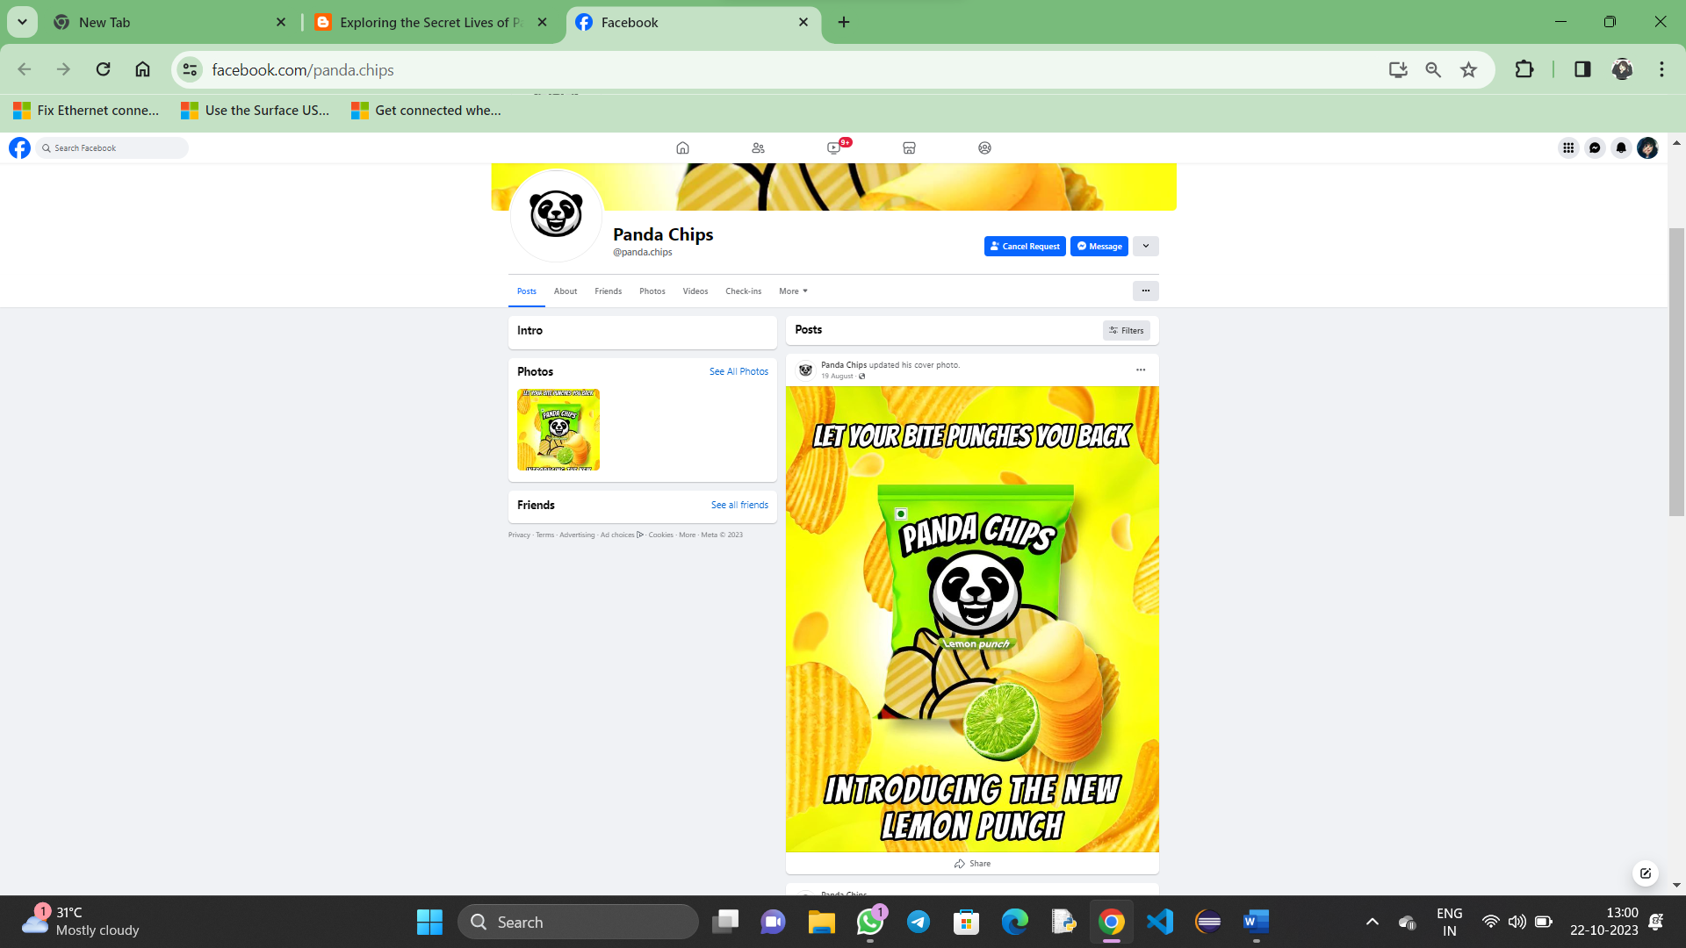

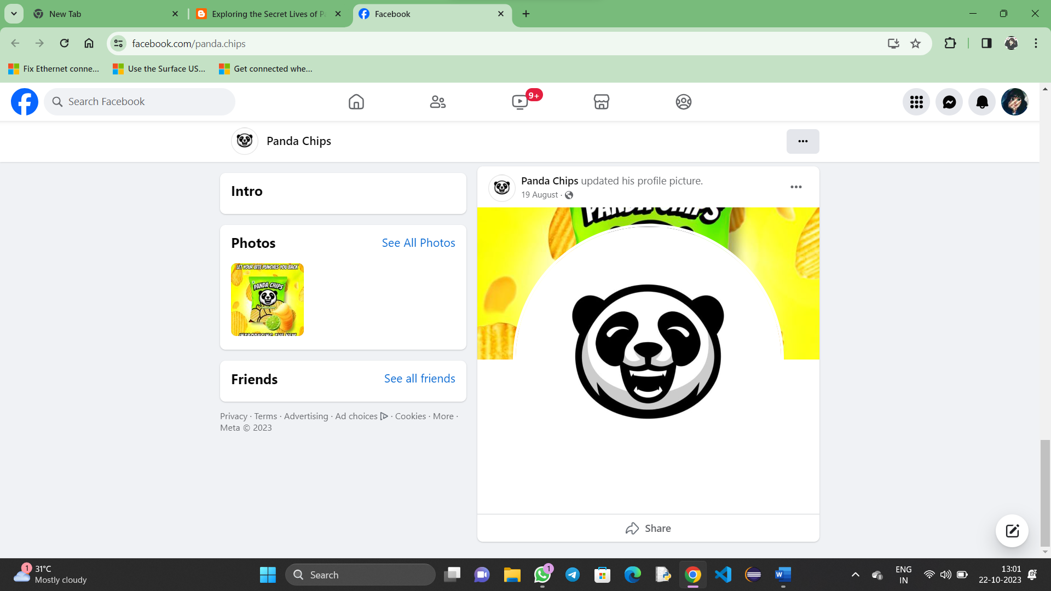

**3**.Create and design a social media advertisement poster using canva

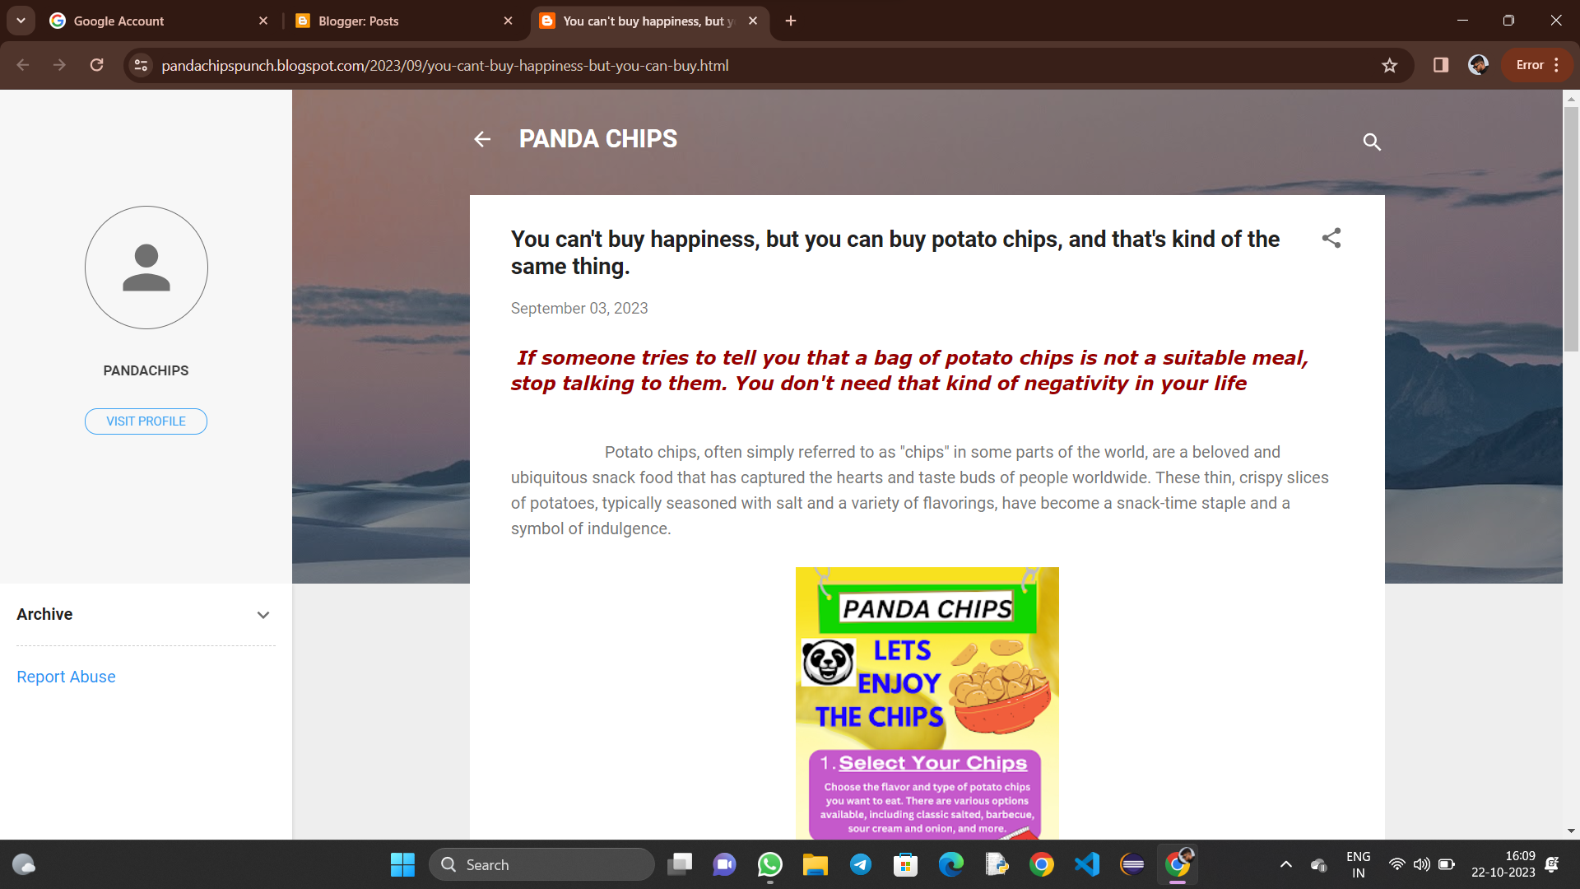 Link: <https://pandachipspunch.blogspot.com/2023/09/you-cant-buy-happiness-but-you-can-buy.html>

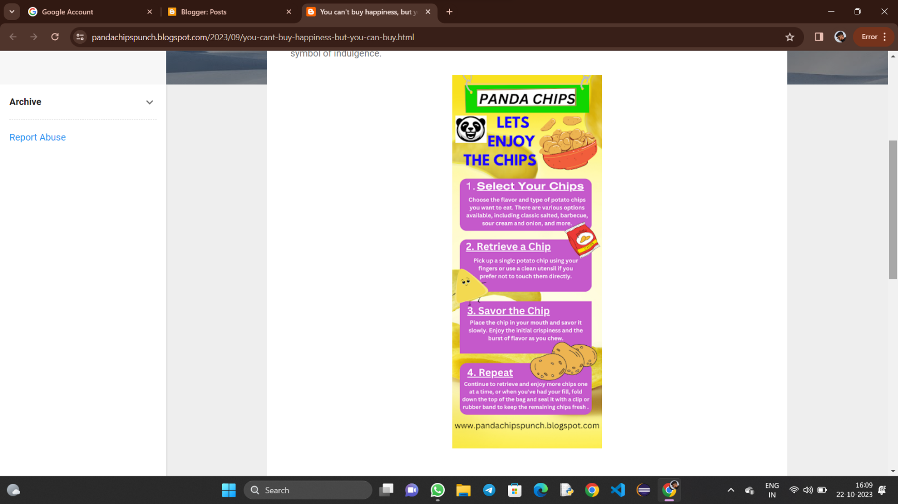

4.Create email newsletter design using MailChimp or canva tool.

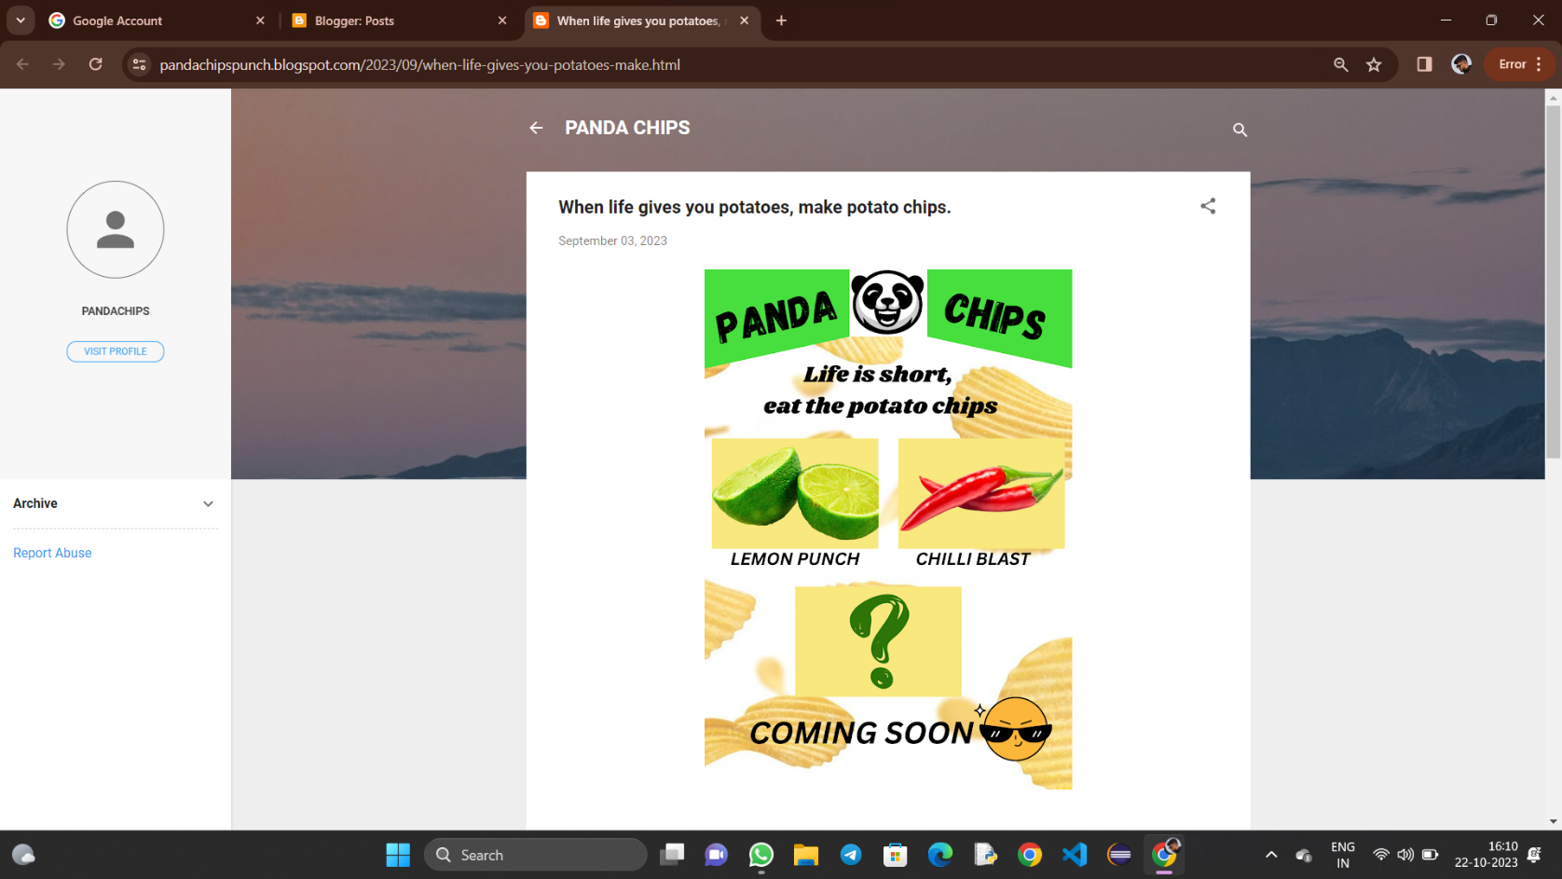Link: <https://pandachipspunch.blogspot.com/2023/09/when-life-gives-you-potatoes-make.html>